**A MINI-PROJECT REPORT ON**

# HOSPITAL MANAGEMENT SYSTEM

## SUBMITTED TO SAVITRIBAI PHULE PUNE UNIVERSITY, PUNE .

**Bachelor of Engineering**

in

## **Computer Engineering**

## **Class: T.E**

### BY

|  |  |
| --- | --- |
| **NAME** | **ROLL NO.** |
| MANASI RENUSE | 38 |
| ANUSHRI PILLAI | 30 |
| RHITIK PRAJAPATI | 31 |
| HARSH PATIL | 23 |

**Under the guidance of**

## Ms.HEMA KUMBHAR



**DEPARTMENT OF COMPUTER ENGINEERING**

**RMD SINHGAD SCHOOL OF ENGINEERING**

WARJE, PUNE-411058

**A.Y: 2023 - 24**



**DEPARTMENT OF COMPUTER ENGINEERING**

**RMD SINHGAD SCHOOL OF ENGINEERING**

WARJE, PUNE-411058

### CERTIFICATE

This is to certify that the Mini-Project Report entitled

**HOSPITAL MANAGEMENT SYSTEM**

SUBMITED BY

**MANASI RENUSE**

is a bonafide work carried out by him/her under the supervision of Mrs.HEMA KUMBHAR and it is submitted towards the partial fulfillment of the requirement for T.E(Computer engineering) – 2019 course of Savitribai Phule Pune University, Pune in the academic year 2023-2024.

|  |  |
| --- | --- |
| **(Mrs.Hema kumbhar)** | Mrs.Vina Lomte |
| Guide | Head, |
| Department of Computer Enginering | Department of Computer Engineering |
| Place:  Date: | **(Dr. V.V. Dixit)**  Principal,  RMD Sinhgad School of Engineering Pune – 58 |

**ACKNOWLEDGEMENT**

We would like to express our sincere gratitude to everyone who contributed to the success of this project. First and foremost, we would like to thank our project supervisor for their valuable guidance, encouragement and support throughout the entire project. We would also like to thank our team members for their hard work, dedication, and collaboration in making this project a reality. Their individual contributions were essential to the overall success of the project. We extend our thanks to the individuals who provided us with access to necessary resources and information that aided our research and analysis. Finally, we want to thank our families and friends for their unwavering support and understanding during the project's development. We are grateful for everyone's support and look forward to further collaborations.

**NAME OF THE STUDENTS**

#### MANASI RENUSE

**CONTENTS**

|  |  |  |
| --- | --- | --- |
| **Sr.No.** | **Contents** | **Page No.** |
| **1.** | Abstract | **1** |
| **2.** | Introduction | **1** |
| **3.** | Data Types | **6** |
| **4.** | Data Requirements  4.1 Requirements Collection and Analysis  4.2 Entities  4.3 Attributes  4.4 Relationships- Cardinality | **6** |
| **5.** | E-R Diagram | **7** |
| **6.** | Schema Diagram | **8** |
| **7** | Relational Database Design | **9** |
| **8.** | Project Outputs  8.1 Sign In  8.2 User  8.3 Admin  8.4 Doctor | **10** |
| **9.** | Test Case Queries | **14** |
| **10.** | Conclusion | **27** |
| **11** | References | **28** |

1. **ABSTRACT**

This project Hospital Management system includes registration of patients, storing their details into the system, and also computerized billing in the pharmacy, and labs. The software has the facility to give a unique id for every patient and stores the clinical details of every patient and hospital tests done automatically. It includes a search facility to know the current status of each patient. User can search details of a patient using the id. The Hospital Management System can be entered using a username and password. It is accessible either by an administrator or receptionist. Only they can add data into the database. The data can be retrieved easily. The interface is very user-friendly. The data are well protected for personal use and makes the data processing very fast.

1. **INTRODUCTION** 
   1. **Problem Statement:**

Design a Hospital Management System to efficiently store, and organizeand manage Hospi- tal and patient related information.

* 1. **Motivation :**

The real motivation for the hospital management system project is to make easy process of all the management process like patients registration, billing, doctors appointment, doctors prescription, etc. We always see that to find out the patient’s history, the user has to go through various registers. This results in wastage of time. So by this system it will become easy to manage all process. So now by taking the motivation of this scenario which was regularly done in hospitals we are designing this system which can be benefited for the patients and hospital staff. So, we'd like to possess this system which help hospital to do work fast and effective. Our present modern information system makes use of computers for the execution, each of them connected through an optimized network. Healthcare is the most critical aspect of our society, and many health care providers face challenges to offer practical and active services to patients.

RMDSSOE, Department of Information Technology, 2022-23 Page 1

**Reasons why you need a Hospital Information System :**



Considering a multispeciality hospital, many people enter and exit the hospital in a day and maintaining their records safely is tedious. To reduce this type of burdens and to manage the financial, hospital administration and clinical aspects, Hospital management system came into existence.

Apart from that automating your hospital's processes and implementing them cannot be done too easily, you need an efficient hospital management system to take care of everything that is happening around the labs and hospitals.

If you are ready to implement or go with the hospital management system, make sure you follow these things before making it useful in your hospitals or labs*.*

* Processing Speed & Results
* Cost Effective
* Reduction in Errors
* Data Security & Retrieving Ability
* Improved Patient Care
* Quality & Compliance **Processing Speed and Results:**

Data Security and Retrieving Ability:

In a Hospital management system, they are one of the cloud-based software where everything gets interlinked, and therefore there are no chances for breaches to occur as they have high data security.

Evidence-based medicine requires the retrieving ability as well as data ability mandatorily, and this easily achieved through a hospital management system. If you have Hospital management system on your hospital, then you can easily access the operational, clinical and financial data of your hospitals*.* **Improved Patient Care:**

Enhanced work efficiency and improved patient data access mean faster and better clinical decisions. A clinician orders the solution to implement once he gets the diagnostic report on his hand, so its necessary to have speedier support for receiving the reports rapidly. All departments in the hospitals are interconnected and integrated with this automation, and this enhances the patient care quality as well as the hospital turnovers.[Hospital f](https://mocdoc.in/blog/a-detailed-view-of-hospital-information-system-his)ollows the standard operating procedures, and there are no chances for deviation to happen in any of the effective HMS systems. With the implementation of HMS in your labs or hospitals, you will be able to treat patients with a better way and accessing their real-time reports and other information regarding the patients, and their past clinical data and more can be done quickly and lead to best patient outcomes. Hospital management system makes employees work more accessible and improve the speed of the complete processes for better results.

**Cost Effective:**

HMS information system helps to track and control finances, reduce leakages as well as reduce manual work and therefore there is no requirement of the higher human workforce. Hospital management system helps to cut down the manual work done by humans in the hospitals especially for the peoples who take care of the record and documentations safely. Hospital management system helps in reducing the human resources costs as most of the work is automated.

Cut down the cost related to storage and other associated requirements. If your hospital is entirely HMS implemented, then your hospital will go paper-free one, it's enough if you maintain the mandatory documents and other related ones in your hospital to comply with the regulation standards.

Reduction in Errors:

hospital management system will help in reducing different types of errors that made through interventions like missing billing, operational failure, clinical errors, cost leakages, missing appointments and much more.

Every process on the hospital management system are automated, and there are plenty of tasks provided to the software to perform without the human intervention as well as accurately, this reduces the error significantly.

For example, An IPD patient final bill amount can be easily generated if your hospital enabled of Hospital management system as his reports and other samples bill are already billed and safe under the Patients unique Hospital ID, and therefore the billing executive needs to generate from the system and provide the statement to the patients.

If your hospital is not HMS enabled then you need to go with manual entries which involves too many human errors, so preferring HMS will make your billing section easier, faster, accurate and more transparent.

**Quality and Compliance:**

Every hospital should send a report of birth, and death occurred, their reasons and related solutions to the NABH accreditation monthly. Its difficult to arrange them manually so preferring the best HMS helps you to send the reports faster and at the right time frame. Every report is monitored and managed in the Hospital Management System carefully and efficiently for the accurate results.

Every one prefers HMS for their hospitals for coordinated and rapid care, reduced costs, reduced waiting time and readmission, enhanced patient safety and clinical care.

Any other essential benefits of implements a hospital management system to your clinics?

Let us know through the comment section below.

**2.3 Objectives :**

i. To implement this application we will require computers in each room of hospital for

e.g. All the wards of hospital should have a computer to update the details about patient. ii. Every patient should be registered, and every person who handles the patients in some or the other way should have a login access to the system so that person can update about the patient relatively.

iii. All the doctors should have a system with internet connection and connected with the other hospital computers.

**3. DATA TYPES:**

In the example MySQL code provided for the bus booking management system, the following data types are used:

1. **`INT`:** Used for representing integer values, such as `bus_id`, `route_id`, `passenger_id`, `reservation_id`, `ticket_id`, and `user_id`, which are used as primary keys or foreign keys in the tables.
2. **`VARCHAR`:** Used for representing string values with variable length, such as `bus_number`, `source`, `destination`, `first_name`, `last_name`, `contact_number`, `username`, `password`, `role`, `seat_number`, and `ticket_status`.
3. **`DATETIME`:** Used for representing date and time values, such as

`reservation_date`, which stores the date and time of a reservation.

1. **`ENUM`:** Used for representing a set of predefined values, such as `status` in the `Reservations` table, which can have values 'booked', 'confirmed', or 'cancelled'.
2. **`DECIMAL`**: Used for representing decimal numbers with a specified precision and scale, such as `capacity` in the `Buses` table and `fare` in the `Routes` and `Tickets` tables.

1. **DATA REQUIREMENTS**

* 1. **Requirements Collection and Analysis**
  2. **Entity Types, Entity Sets**
  3. **Attributes, and Keys**

**4.4Relationships- Cardinality**

1. **E-R DIAGRAM :**

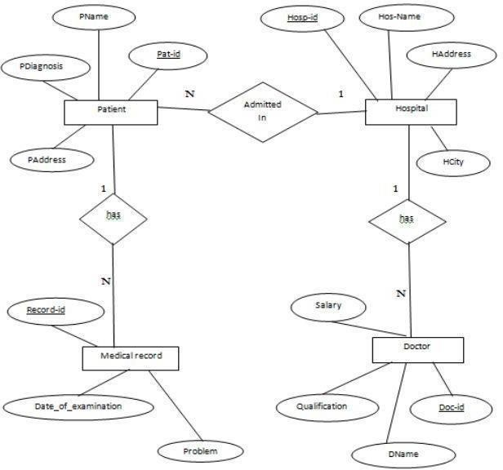

1. **SCHEMA DIAGRAM :**

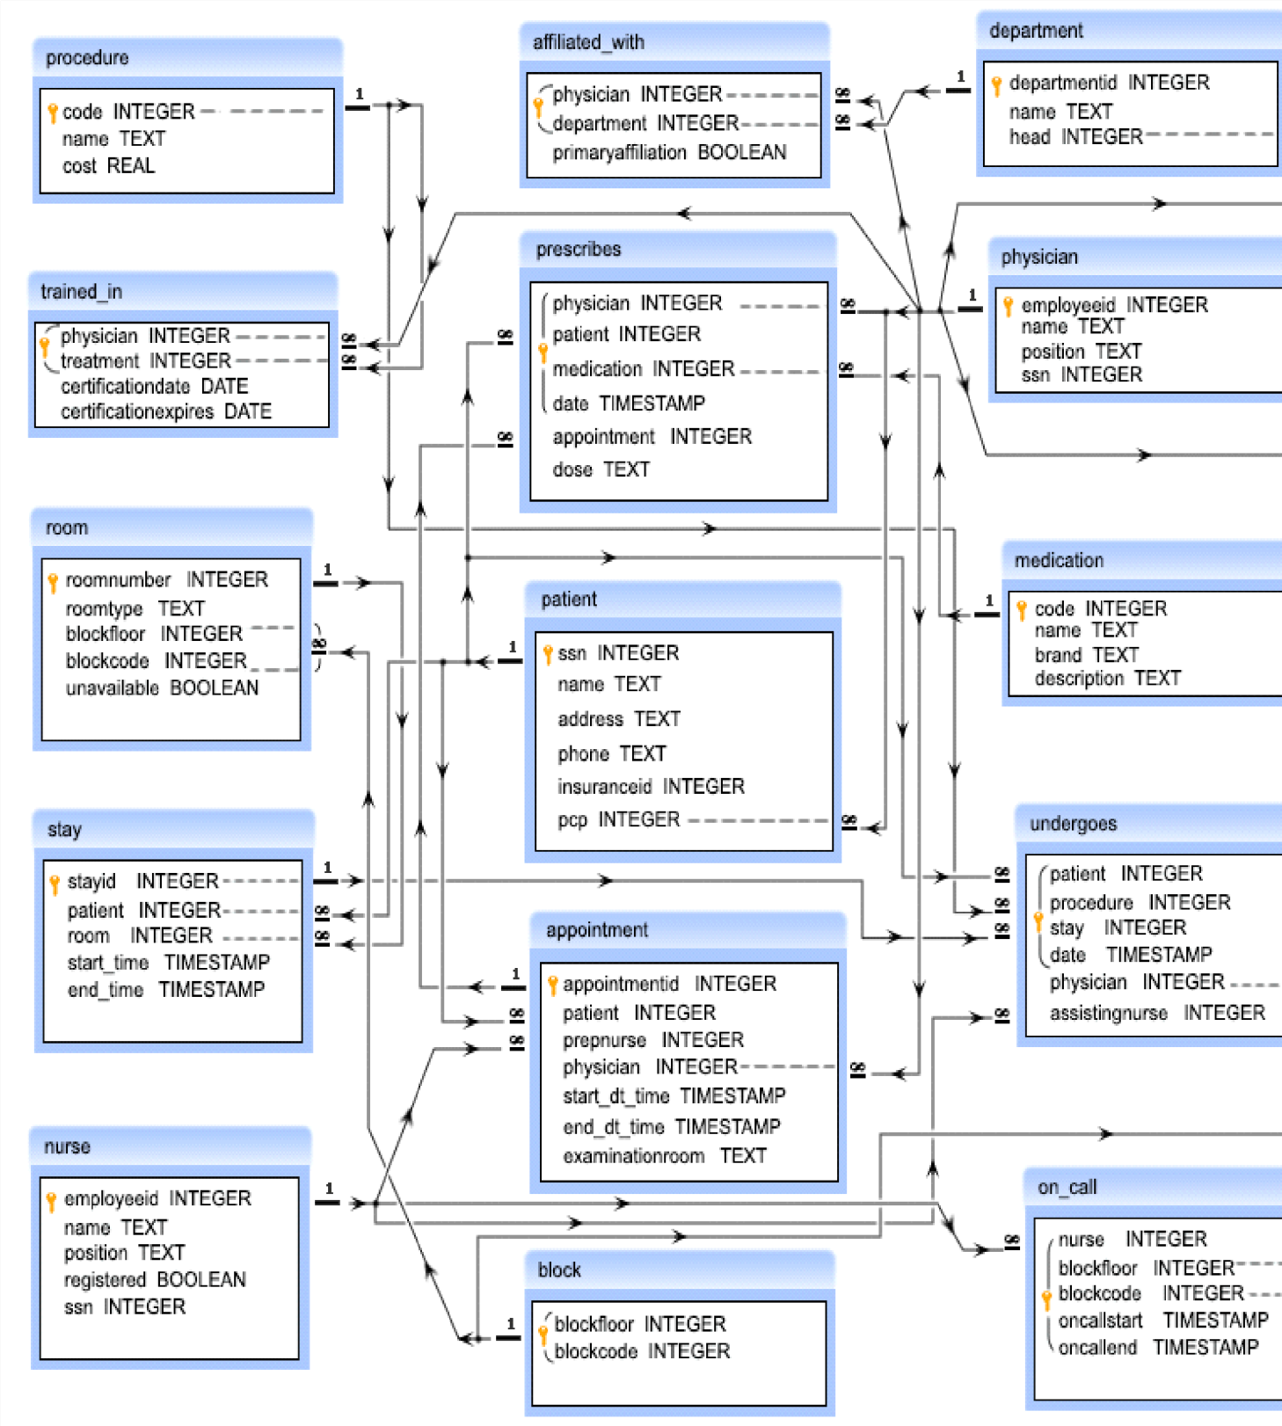

1. **RELATIONAL DATABASE DESIGN:**

After designing the ER diagram of the system, we need to convert it to Relational models which can be directly implemented by any RDBMS like Oracle, MySQL etc. Relational database design (RDD) models information and data into a record, and each column represents an attribute of data. The Structured Query Language (SQL) is used to manipulate relational databases.

Design of relational Database in MySQL using E-R diagram: Mapping Entities:

For every Entity in ER model, a table is created in Relational Model. The attributes if the Entity gets converted to columns of the table and the primary key specified for the entity in the ER model, will become the primary key for the table in the relational model

**8.1PROJECT OUTPUTS**

**IMPLEMENTATION**

* 1. **Sign In**



* 1. **User**

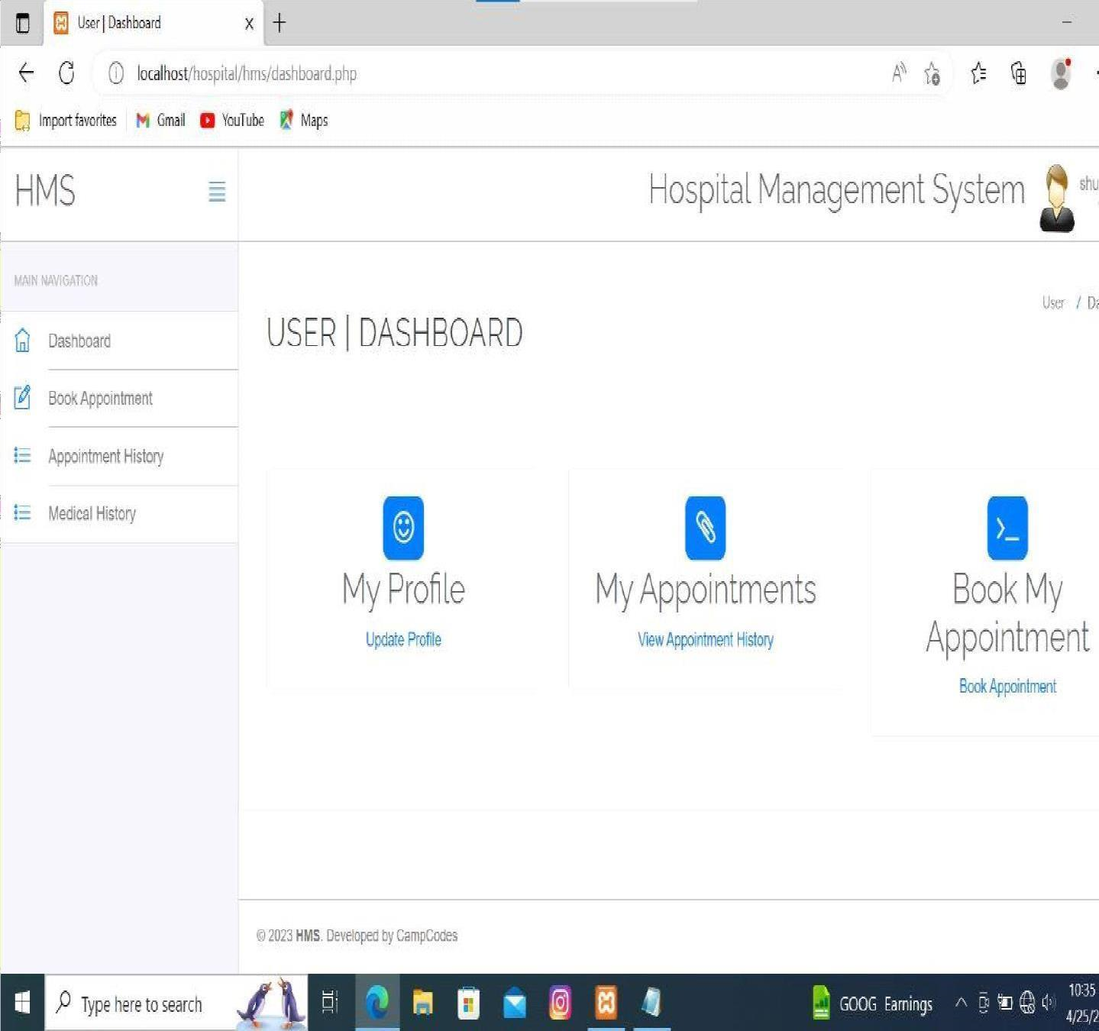

* 1. **Admin**

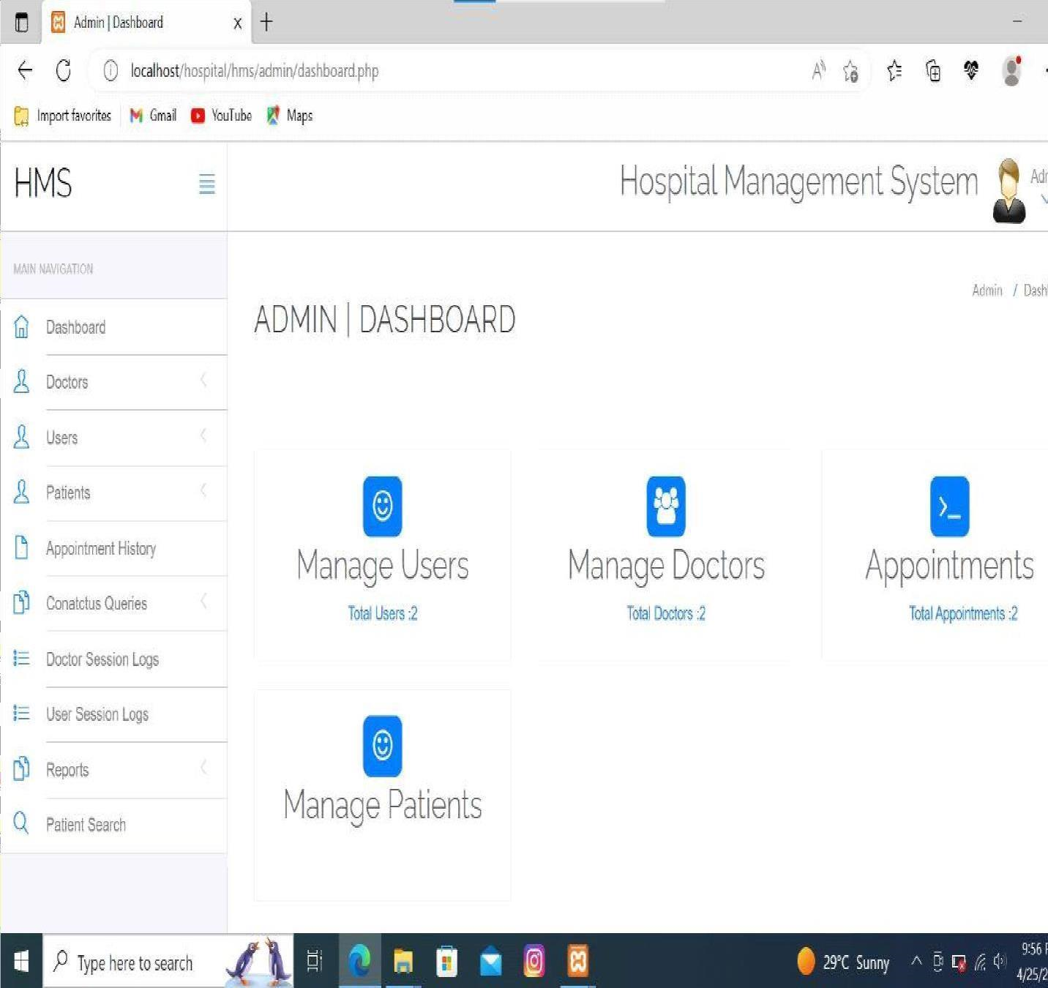

* 1. **Doctor**

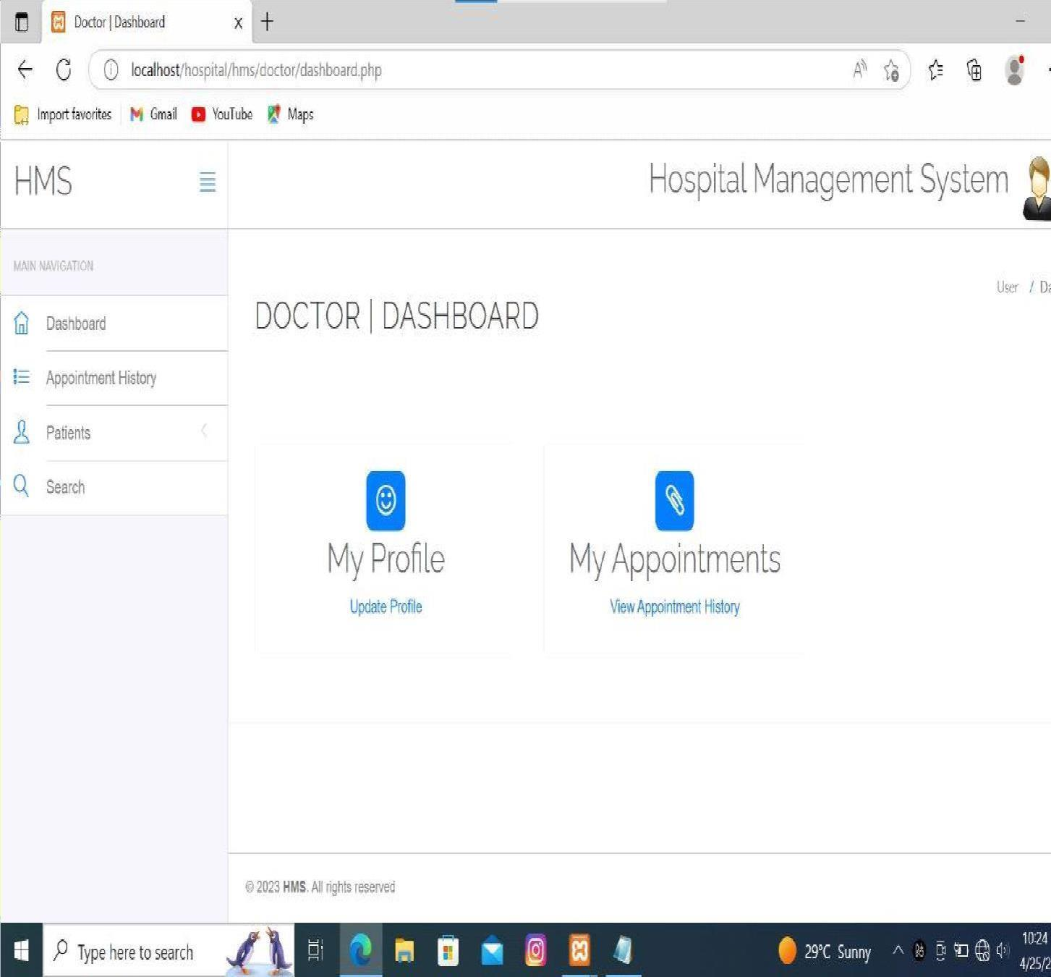

|  |
| --- |
| HOSPITAL MANAGEMENT SYSTEM  **9. Test Case Queries :**    phpMyAdmin SQL Dump  version 5.0.2  https://www.phpmyadmin.net/  Host: 127.0.0.1  Generation Time: Jul 05, 2020 at 04:35 AM  Server version: 10.4.13-MariaDB  PHP Version: 7.4.7  SET SQL_MODE = "NO_AUTO_VALUE_ON_ZERO";  START TRANSACTION;  SET time_zone = "+00:00";    /*!40101 SET @OLD_CHARACTER_SET_CLIENT=@@CHARACTER_SET_CLIENT  */;  /*!40101 SET  @OLD_CHARACTER_SET_RESULTS=@@CHARACTER_SET_RESULTS */;  /*!40101 SET  @OLD_COLLATION_CONNECTION=@@COLLATION_CONNECTION */;  /*!40101 SET NAMES utf8mb4 */;  Database: `hms`  Table structure for table `admin`  CREATE TABLE `admin` (  `id` int(11) NOT NULL,  `username` varchar(255) NOT NULL,  `password` varchar(255) NOT NULL,  `updationDate` varchar(255) NOT NULL    ) ENGINE=InnoDB DEFAULT CHARSET=latin1;  RMDSSOE, Department of Information Technology, 2022-23 Page 14 |

Dumping data for table `admin`

INSERT INTO `admin` (`id`, `username`, `password`, `updationDate`) VALUES

(1, 'admin', 'Test@12345', '28-12-2016 11:42:05 AM');

Table structure for table `appointment`

CREATE TABLE `appointment` (

`id` int(11) NOT NULL,

`doctorSpecialization` varchar(255) DEFAULT NULL,

`doctorId` int(11) DEFAULT NULL,

`userId` int(11) DEFAULT NULL,

`consultancyFees` int(11) DEFAULT NULL,

`appointmentDate` varchar(255) DEFAULT NULL,

`appointmentTime` varchar(255) DEFAULT NULL,

`postingDate` timestamp NULL DEFAULT current_timestamp(),

`userStatus` int(11) DEFAULT NULL,

`doctorStatus` int(11) DEFAULT NULL,

`updationDate` timestamp NULL DEFAULT NULL ON UPDATE current_timestamp()

) ENGINE=InnoDB DEFAULT CHARSET=latin1;

Dumping data for table `appointment`

INSERT INTO `appointment` (`id`, `doctorSpecialization`, `doctorId`, `userId`,

`consultancyFees`, `appointmentDate`, `appointmentTime`, `postingDate`, `userStatus`,

`doctorStatus`, `updationDate`) VALUES

(3, 'Demo test', 7, 6, 600, '2019-06-29', '9:15 AM', '2019-06-23 18:31:28', 1, 0, '0000-00-00 00:00:00'),

(4, 'Ayurveda', 5, 5, 8050, '2019-11-08', '1:00 PM', '2019-11-05 10:28:54', 1, 1, '0000-00-00 00:00:00'),

(5, 'Dermatologist', 9, 7, 500, '2019-11-30', '5:30 PM', '2019-11-10 18:41:34', 1, 0, '201911-10 18:48:30'),

(6, 'Physician', 11, 2, 2000, '2020-07-14', '10:15 AM', '2020-07-05 02:12:37', 1, 1, NULL),

(7, 'General Physician', 3, 2, 1200, '2020-07-05', '10:15 AM', '2020-07-05 02:14:49', 1, 1,

NULL);

Table structure for table `doctors`

CREATE TABLE `doctors` (

`id` int(11) NOT NULL,

`specilization` varchar(255) DEFAULT NULL,

`doctorName` varchar(255) DEFAULT NULL,

`address` longtext DEFAULT NULL,

`docFees` varchar(255) DEFAULT NULL,

`contactno` bigint(11) DEFAULT NULL,

`docEmail` varchar(255) DEFAULT NULL,

`password` varchar(255) DEFAULT NULL,

`creationDate` timestamp NULL DEFAULT current_timestamp(),

`updationDate` timestamp NULL DEFAULT NULL ON UPDATE current_timestamp()

) ENGINE=InnoDB DEFAULT CHARSET=latin1;

Dumping data for table `doctors`

INSERT INTO `doctors` (`id`, `specilization`, `doctorName`, `address`, `docFees`,

`contactno`, `docEmail`, `password`, `creationDate`, `updationDate`) VALUES

(1, 'Dentist', 'Lyndon Bermoy', 'New Delhi', '500', 8285703354, 'anuj.lpu1@gmail.com', 'f925916e2754e5e03f75dd58a5733251', '2016-12-29 06:25:37', '2020-07-05 01:53:19'),

(2, 'Homeopath', 'Sarita Pandey', 'Varanasi', '600', 2147483647, 'sarita@gmail.com',

'f925916e2754e5e03f75dd58a5733251', '2016-12-29 06:51:51', '0000-00-00 00:00:00'), (3, 'General Physician', 'Nitesh Kumar', 'Ghaziabad', '1200', 8523699999,

'nitesh@gmail.com', 'f925916e2754e5e03f75dd58a5733251', '2017-01-07 07:43:35',

'0000-00-00 00:00:00'),

(4, 'Homeopath', 'Vijay Verma', 'New Delhi', '700', 25668888, 'vijay@gmail.com',

'f925916e2754e5e03f75dd58a5733251', '2017-01-07 07:45:09', '0000-00-00 00:00:00'),

(5, 'Ayurveda', 'Sanjeev', 'Gurugram', '8050', 442166644646, 'sanjeev@gmail.com',

'f925916e2754e5e03f75dd58a5733251', '2017-01-07 07:47:07', '0000-00-00 00:00:00'),

(6, 'General Physician', 'Amrita', 'New Delhi India', '2500', 45497964, 'amrita@test.com',

'f925916e2754e5e03f75dd58a5733251', '2017-01-07 07:52:50', '0000-00-00 00:00:00'),

(7, 'Demo test', 'abc ', 'New Delhi India', '200', 852888888, 'test@demo.com',

'f925916e2754e5e03f75dd58a5733251', '2017-01-07 08:08:58', '2019-06-23 18:17:25'),

(8, 'Ayurveda', 'Test Doctor', 'Xyz Abc New Delhi', '600', 1234567890, 'test@test.com',

'202cb962ac59075b964b07152d234b70', '2019-06-23 17:57:43', '2019-06-23 18:06:06'),

(11, 'Physician', 'Jonah Juarez', 'Surigao Philippines', '2000', 123456789,

'jjuarez@gmail.com', '25f9e794323b453885f5181f1b624d0b', '2020-07-05 02:06:00',

'2020-07-05 02:06:48');

Table structure for table `doctorslog`

CREATE TABLE `doctorslog` (

`id` int(11) NOT NULL,

`uid` int(11) DEFAULT NULL,

`username` varchar(255) DEFAULT NULL,

`userip` binary(16) DEFAULT NULL,

`loginTime` timestamp NULL DEFAULT current_timestamp(),

`logout` varchar(255) DEFAULT NULL,

`status` int(11) DEFAULT NULL

) ENGINE=InnoDB DEFAULT CHARSET=latin1;

Dumping data for table `doctorslog`

INSERT INTO `doctorslog` (`id`, `uid`, `username`, `userip`, `loginTime`, `logout`,

`status`) VALUES

(20, 7, 'test@demo.com', 0x3a3a3100000000000000000000000000, '2020-07-05

01:50:01', NULL, 1),

(21, NULL, 'juarez@gmail.com', 0x3a3a3100000000000000000000000000, '2020-07-05

02:02:51', NULL, 0),

(22, NULL, 'juarez@gmail.com', 0x3a3a3100000000000000000000000000, '2020-07-05

02:03:03', NULL, 0),

(23, NULL, 'jjuarez@gmail.com', 0x3a3a3100000000000000000000000000, '2020-07-05

02:04:02', NULL, 0),

(24, NULL, 'jjuarez@gmail.com', 0x3a3a3100000000000000000000000000, '2020-07-05

02:04:38', NULL, 0),

(25, 11, 'jjuarez@gmail.com', 0x3a3a3100000000000000000000000000, '2020-07-05

02:06:19', NULL, 1),

(26, 11, 'jjuarez@gmail.com', 0x3a3a3100000000000000000000000000, '2020-07-05

02:06:38', NULL, 1),

(27, 11, 'jjuarez@gmail.com', 0x3a3a3100000000000000000000000000, '2020-07-05

02:08:18', NULL, 1),

(28, 11, 'jjuarez@gmail.com', 0x3a3a3100000000000000000000000000, '2020-07-05

02:15:25', NULL, 1);

Table structure for table `doctorspecilization`

CREATE TABLE `doctorspecilization` (

`id` int(11) NOT NULL,

`specilization` varchar(255) DEFAULT NULL,

`creationDate` timestamp NULL DEFAULT current_timestamp(),

`updationDate` timestamp NULL DEFAULT NULL ON UPDATE current_timestamp()

) ENGINE=InnoDB DEFAULT CHARSET=latin1;

Dumping data for table `doctorspecilization`

INSERT INTO `doctorspecilization` (`id`, `specilization`, `creationDate`, `updationDate`)

VALUES

(1, 'Gynecologist/Obstetrician', '2016-12-28 06:37:25', '0000-00-00 00:00:00'),

(2, 'General Physician', '2016-12-28 06:38:12', '0000-00-00 00:00:00'),

(3, 'Dermatologist', '2016-12-28 06:38:48', '0000-00-00 00:00:00'),

(4, 'Homeopath', '2016-12-28 06:39:26', '0000-00-00 00:00:00'),

(5, 'Ayurveda', '2016-12-28 06:39:51', '0000-00-00 00:00:00'),

(6, 'Dentist', '2016-12-28 06:40:08', '0000-00-00 00:00:00'),

(7, 'Ear-Nose-Throat (Ent) Specialist', '2016-12-28 06:41:18', '0000-00-00 00:00:00'),

(9, 'Demo test', '2016-12-28 07:37:39', '0000-00-00 00:00:00'),

(10, 'Bones Specialist demo', '2017-01-07 08:07:53', '0000-00-00 00:00:00'),

(11, 'Test', '2019-06-23 17:51:06', '2019-06-23 17:55:06'),

(12, 'Dermatologist', '2019-11-10 18:36:36', '2019-11-10 18:36:50'),

(13, 'Physician', '2020-07-05 01:59:00', NULL);

Table structure for table `tblcontactus`

CREATE TABLE `tblcontactus` (

`id` int(11) NOT NULL,

`fullname` varchar(255) DEFAULT NULL,

`email` varchar(255) DEFAULT NULL,

`contactno` bigint(12) DEFAULT NULL,

`message` mediumtext DEFAULT NULL,

`PostingDate` timestamp NULL DEFAULT current_timestamp(),

`AdminRemark` mediumtext DEFAULT NULL,

`LastupdationDate` timestamp NULL DEFAULT NULL ON UPDATE current_timestamp(),

`IsRead` int(11) DEFAULT NULL

) ENGINE=InnoDB DEFAULT CHARSET=latin1;

Dumping data for table `tblcontactus`

INSERT INTO `tblcontactus` (`id`, `fullname`, `email`, `contactno`, `message`,

`PostingDate`, `AdminRemark`, `LastupdationDate`, `IsRead`) VALUES

(1, 'test user', 'test@gmail.com', 2523523522523523, ' This is sample text for the test.',

'2019-06-29 19:03:08', 'Test Admin Remark', '2019-06-30 12:55:23', 1),

(2, 'Lyndon Bermoy', 'serbermz2020@gmail.com', 1111111111111111, ' This is sample text for testing. This is sample text for testing. This is sample text for testing. This is sample text for testing. This is sample text for testing. This is sample text for testing. This is sample text for testing. This is sample text for testing. This is sample text for testing. This is sample text for testing. This is sample text for testing. This is sample text for testing. This is sample text for testing. This is sample text for testing. This is sample text for testing. This is sample text for testing. This is sample text for testing. This is sample text for testing. This is sample text for testing. This is sample text for testing. This is sample text for testing. This is sample text for testing.', '2019-06-30 13:06:50', 'Answered', '202007-05 02:13:25', 1),

(3, 'fdsfsdf', 'fsdfsd@ghashhgs.com', 3264826346, 'sample text sample text sample text sample text sample text sample text sample text sample text sample text sample text sample text sample text sample text sample text sample text sample text sample text sample text sample text sample text sample text sample text sample text sample text ',

'2019-11-10 18:53:48', 'vfdsfgfd', '2019-11-10 18:54:04', 1),

(4, 'demo', 'demo@gmail.com', 123456789, ' hi, this is a demo', '2020-07-05 01:57:20',

'answered', '2020-07-05 01:57:46', 1);

Table structure for table `tblmedicalhistory`

CREATE TABLE `tblmedicalhistory` (

`ID` int(10) NOT NULL,

`PatientID` int(10) DEFAULT NULL,

`BloodPressure` varchar(200) DEFAULT NULL,

`BloodSugar` varchar(200) NOT NULL,

`Weight` varchar(100) DEFAULT NULL,

`Temperature` varchar(200) DEFAULT NULL,

`MedicalPres` mediumtext DEFAULT NULL,

`CreationDate` timestamp NOT NULL DEFAULT current_timestamp() ON UPDATE current_timestamp()

) ENGINE=InnoDB DEFAULT CHARSET=latin1;

Dumping data for table `tblmedicalhistory`

INSERT INTO `tblmedicalhistory` (`ID`, `PatientID`, `BloodPressure`, `BloodSugar`,

`Weight`, `Temperature`, `MedicalPres`, `CreationDate`) VALUES (2, 3, '120/185', '80/120', '85 Kg', '101 degree', '#Fever, #BP high\r\n1.Paracetamol\r\n2.jocib tab\r\n', '2019-11-06 04:20:07'),

(3, 2, '90/120', '92/190', '86 kg', '99 deg', '#Sugar High\r\n1.Petz 30', '2019-11-06 04:31:24'),

(4, 1, '125/200', '86/120', '56 kg', '98 deg', '# blood pressure is high\r\n1.koil cipla', '201911-06 04:52:42'),

(5, 1, '96/120', '98/120', '57 kg', '102 deg', '#Viral\r\n1.gjgjh-1Ml\r\n2.kjhuiy-2M', '201911-06 04:56:55'),

(6, 4, '90/120', '120', '56', '98 F', '#blood sugar high\r\n#Asthma problem', '2019-11-06 14:38:33'),

(7, 5, '80/120', '120', '85', '98.6', 'Rx\r\n\r\nAbc tab\r\nxyz Syrup', '2019-11-10 18:50:23');

Table structure for table `tblpatient`

CREATE TABLE `tblpatient` (

`ID` int(10) NOT NULL,

`Docid` int(10) DEFAULT NULL,

`PatientName` varchar(200) DEFAULT NULL,

`PatientContno` bigint(10) DEFAULT NULL,

`PatientEmail` varchar(200) DEFAULT NULL,

`PatientGender` varchar(50) DEFAULT NULL,

`PatientAdd` mediumtext DEFAULT NULL,

`PatientAge` int(10) DEFAULT NULL,

`PatientMedhis` mediumtext DEFAULT NULL,

`CreationDate` timestamp NULL DEFAULT current timestamp(),

`UpdationDate` timestamp NULL DEFAULT NULL ON UPDATE current_timestamp()

) ENGINE=InnoDB DEFAULT CHARSET=latin1;

Dumping data for table `tblpatient`

INSERT INTO `tblpatient` (`ID`, `Docid`, `PatientName`, `PatientContno`, `PatientEmail`,

`PatientGender`, `PatientAdd`, `PatientAge`, `PatientMedhis`, `CreationDate`,

`UpdationDate`) VALUES

(1, 1, 'Manisha Jha', 4558968789, 'test@gmail.com', 'Female', '\"\"J&K Block J-127,

Laxmi Nagar New Delhi', 26, 'She is diabetic patient', '2019-11-04 21:38:06', '2019-11-06 06:48:05'),

(4, 7, 'Manav Sharma', 9888988989, 'sharma@gmail.com', 'Male', 'L-56,Ashok Nagar New

Delhi-110096', 45, 'He is long suffered by asthma', '2019-11-06 14:33:54', '2019-11-06 14:34:31'),

(5, 9, 'John', 1234567890, 'john@test.com', 'male', 'Test ', 25, 'THis is sample text for testing.', '2019-11-10 18:49:24', NULL),

(6, 0, 'Don Bermoy', 123456789, 'serbermz2020@gmail.com', 'male', 'Surigao Philippines',

35, 'Diagnosed of High Blood Pressure', '2020-07-05 02:08:09', NULL);

Table structure for table `userlog`

CREATE TABLE `userlog` (

`id` int(11) NOT NULL,

`uid` int(11) DEFAULT NULL,

`username` varchar(255) DEFAULT NULL,

`userip` binary(16) DEFAULT NULL,

`loginTime` timestamp NULL DEFAULT current_timestamp(),

`logout` varchar(255) DEFAULT NULL,

`status` int(11) DEFAULT NULL

) ENGINE=InnoDB DEFAULT CHARSET=latin1;

Dumping data for table `userlog`

INSERT INTO `userlog` (`id`, `uid`, `username`, `userip`, `loginTime`, `logout`, `status`)

VALUES

(24, 2, 'test@gmail.com', 0x3a3a3100000000000000000000000000, '2020-07-05

01:50:24', NULL, 1),

(25, NULL, 'serbermz2020@gmail.com', 0x3a3a3100000000000000000000000000, '2020-07-05 02:09:18', NULL, 0),

(26, NULL, 'serbermz2020@gmail.com', 0x3a3a3100000000000000000000000000,

'2020-07-05 02:11:05', NULL, 0),

(27, NULL, 'test@demo.com', 0x3a3a3100000000000000000000000000, '2020-07-05

02:11:24', NULL, 0),

(28, NULL, 'serbermz2020@gmail.com', 0x3a3a3100000000000000000000000000,

'2020-07-05 02:11:46', NULL, 0),

(29, 2, 'test@gmail.com', 0x3a3a3100000000000000000000000000, '2020-07-05

02:12:00', NULL, 1);

Table structure for table `users`

CREATE TABLE `users` (

`id` int(11) NOT NULL,

`fullName` varchar(255) DEFAULT NULL,

`address` longtext DEFAULT NULL, `city` varchar(255) DEFAULT NULL,

`gender` varchar(255) DEFAULT NULL,

`email` varchar(255) DEFAULT NULL,

`password` varchar(255) DEFAULT NULL,

`regDate` timestamp NULL DEFAULT current_timestamp(),

`updationDate` timestamp NULL DEFAULT NULL ON UPDATE current_timestamp()

) ENGINE=InnoDB DEFAULT CHARSET=latin1;

INSERT INTO `users` (`id`, `fullName`, `address`, `city`, `gender`, `email`, `password`,

`regDate`, `updationDate`) VALUES

(2, 'Demo User', 'Manila, Philippines', 'Delhi', 'female', 'test@gmail.com',

'f925916e2754e5e03f75dd58a5733251', '2016-12-30 05:34:39', '2020-07-05 01:55:24');

Indexes for dumped tables

Indexes for table `admin`

ALTER TABLE `admin` ADD PRIMARY KEY (`id`);

Indexes for table `appointment`

ALTER TABLE `appointment`

ADD PRIMARY KEY (`id`);

Indexes for table `doctors`

ALTER TABLE `doctors` ADD PRIMARY KEY (`id`);

Indexes for table `doctorslog`

ALTER TABLE `doctorslog`

ADD PRIMARY KEY (`id`);

Indexes for table `doctorspecilization`

ALTER TABLE `doctorspecilization`

ADD PRIMARY KEY (`id`);

Indexes for table `tblcontactus` ALTER TABLE `tblcontactus`

ADD PRIMARY KEY (`id`);

Indexes for table `tblmedicalhistory`

ALTER TABLE `tblmedicalhistory` ADD PRIMARY KEY (`ID`); Indexes for table `tblpatient`

ALTER TABLE `tblpatient` ADD PRIMARY KEY (`ID`);

Indexes for table `userlog` ALTER TABLE `userlog` ADD PRIMARY KEY (`id`);

Indexes for table `users`

ALTER TABLE `users`

ADD PRIMARY KEY (`id`),

ADD KEY `email` (`email`);

AUTO_INCREMENT for dumped tables

AUTO_INCREMENT for table `admin`

ALTER TABLE `admin`

MODIFY `id` int(11) NOT NULL AUTO_INCREMENT, AUTO_INCREMENT=2;

AUTO_INCREMENT for table `appointment`

ALTER TABLE `appointment`

MODIFY `id` int(11) NOT NULL AUTO_INCREMENT, AUTO_INCREMENT=8;

AUTO_INCREMENT for table `doctors`

ALTER TABLE `doctors`

MODIFY `id` int(11) NOT NULL AUTO_INCREMENT, AUTO_INCREMENT=12;

AUTO_INCREMENT for table `doctorslog`

ALTER TABLE `doctorslog`

MODIFY `id` int(11) NOT NULL AUTO_INCREMENT, AUTO_INCREMENT=29;

AUTO_INCREMENT for table `doctorspecilization`

ALTER TABLE `doctorspecilization`

MODIFY `id` int(11) NOT NULL AUTO_INCREMENT, AUTO_INCREMENT=14;

AUTO_INCREMENT for table `tblcontactus`

ALTER TABLE `tblcontactus`

MODIFY `id` int(11) NOT NULL AUTO_INCREMENT, AUTO_INCREMENT=5; AUTO_INCREMENT for table `tblmedicalhistory`

ALTER TABLE `tblmedicalhistory`

MODIFY `ID` int(10) NOT NULL AUTO_INCREMENT, AUTO_INCREMENT=8;

AUTO_INCREMENT for table `tblpatient`

ALTER TABLE `tblpatient`

MODIFY `ID` int(10) NOT NULL AUTO_INCREMENT, AUTO_INCREMENT=7;

AUTO_INCREMENT for table `userlog`

ALTER TABLE `userlog`

MODIFY `id` int(11) NOT NULL AUTO_INCREMENT, AUTO_INCREMENT=30;

AUTO_INCREMENT for table `users`

ALTER TABLE `users`

MODIFY `id` int(11) NOT NULL AUTO_INCREMENT, AUTO_INCREMENT=8;

COMMIT;

/*!40101 SET CHARACTER_SET_CLIENT=@OLD_CHARACTER_SET_CLIENT */;

/*!40101 SET CHARACTER_SET_RESULTS=@OLD_CHARACTER_SET_RESULTS

*/;

/*!40101 SET COLLATION_CONNECTION=@OLD_COLLATION_CONNECTION */;

**10.Conclusion :**

This can be a powerful tool to help healthcare organizations improve their processes and streamline their operations. It can provide an integrated, comprehensive solution to managing patient records, billing and scheduling, as well as provide real-time insights into hospital performance. When used correctly and effectively,a hospital management system can help hospitals ensure that their operations are as efficient and effective as possible.

11.**References :**

1. Green, J and Armstrong, D (1994), “The views of service providers”, in Morrell D, Green J, Armstrong D,Bartholomew J, Gelder F, Jenkins C, Jankowski R, Mandalia S, Britten N, Shaw A and Savill R, Five essays onemergency pathways, Kings Fund Institute, for the Kings Fund Commission on the future of AcuteServices inLondon, Kings Fund, London.
2. www.hotscripts.com/category/**php**/
3. [www.**mysql**.com/click.php?e=35050](http://www.mysql.com/click.php?e=35050)
4. Audit Commission (1992), Lying in Waitthe use medical beds in acute hospitals ,London.
5. Emergency Services Action Team (1998), Report - Winter 1997/8, Department of Health.
6. Boaden R, Proudlove N and Wilson M (1998), Evaluation of the “Managing Emergency Delivery” Project:Report on Stage 2, NHS Executive (North West) R&D Directorate.
7. <https://nptel.ac.in/courses/106/105/106105175/>
8. Brown, C (1999), “Winter happens every year”, Managing an Effective Bed Management System in theNHS